**Guvi Zen DB IN MYSQL**

*Creating a table for student data

create table Student (

id integer,

Student_Name text,

Codekata_solved integer,

Batch text,

Course text,

Task integer

)

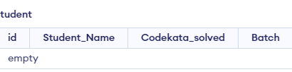

*Inserting Student

Insert into Student values(1,"Sundar",160,"B48WD1/Tamil","Full stack Development",3)

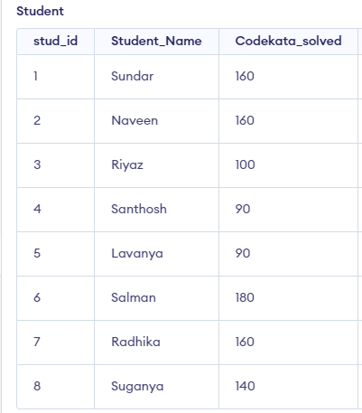

# Remaining student columns below

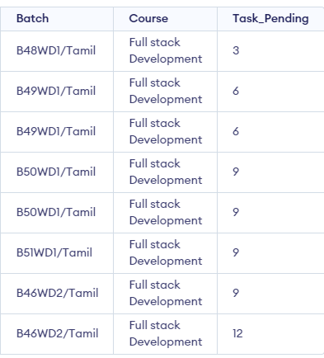

**Mentor Table**

create table Mentor (

id integer,

Name text,

Batch text,

Batch_timing text,

Batch_id text

)

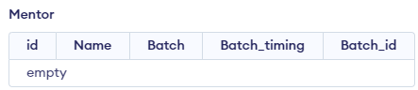

*Inserting values in mentor table

Insert into Mentor values(1,"Sanjay","Full stack development","8am-11am","B51WD2/Tamil")

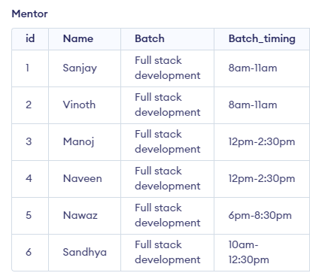 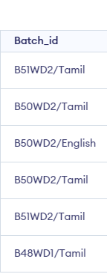

*Total count of batches

select * , count() From Mentor group by Batch_id

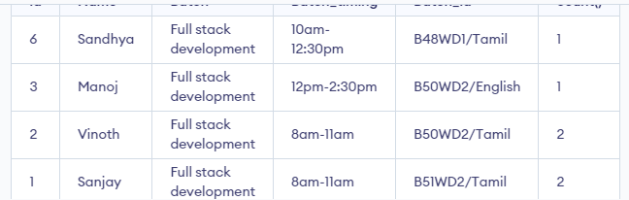

*Joining mentor and student table

*Mentor with student details and batch,batch_timings

select Name,Student_Name,Batch_timing,Batch_id From Mentor join Student on id = student.stud_id

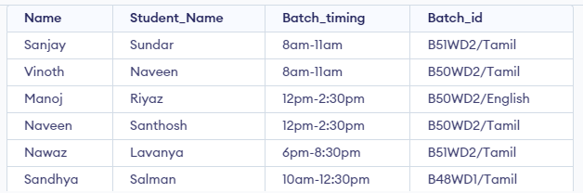

*Highest solved codekata student name and codekata score

select Student_Name,max(Codekata_solved) as Highest_Codekata_score From Student



*Lowest Solved codekata student name and codekata score

select Student_Name,min(Codekata_solved) as Lowest_Codekata_score From Student;



Task pending students

select Student_name,Task_Pending From Student;

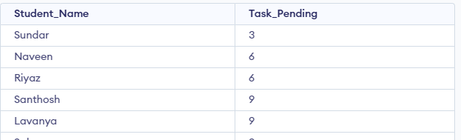 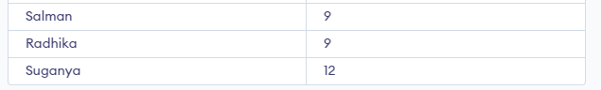

*High task pending by students

Select student_Name , max(Task_Pending) From Student



*Updating mentor batch timings

*Changing Mentor sanjay batch timing

update Mentor set Batch_timing = "8am - 10:30am" where id = 1

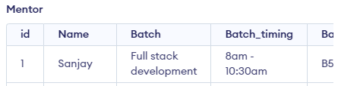

*Updating Two columns

*Timing and batch id

*Changing batch timing and batch id tamil to English

update Mentor set Batch_timing = "8am - 10:30am",Batch_id = "B50WD2/English" where id = 2

 

*Deleting a student

*Deleting student of batch id b46wd2/tamil

Delete From Student where Batch = "B46WD2/Tamil"

